Currently we gather at:
Innovox Lounge at 7:00 pm on the first and third Thursday of every month.
www.innovoxlounge.com/thecoffeehouse.html

For more of these ideas, please read Ishmael (1992), Providence: The Story of a Fifty-Year Vision Quest (1995), The Story of B (1996), My Ishmael (1997), Beyond Civilization: Humanity’s Next Great Adventure (1999),and The Man Who Grew Young (2001) by Daniel Quinn. All of these books should be available through your local library (though you may need to request them) as well as most booksellers. Also, please visit the free Ishmael Community website, www.ishmael.org

To contact someone in Atlanta about these ideas, please send an e-mail to: pvanhugen@hotmail.com
or visit
http://groups.yahoo.com/
group/ATLeavers
In 1989 Ted Turner created a fellowship to be awarded to a work of fiction offering positive solutions to global problems. The winner, chosen from 2500 entries worldwide, was a work of startling clarity and depth: Daniel Quinn’s ISHMAEL, a Socratic journey that explores the most challenging problem humankind has ever faced: How to save the world from ourselves.
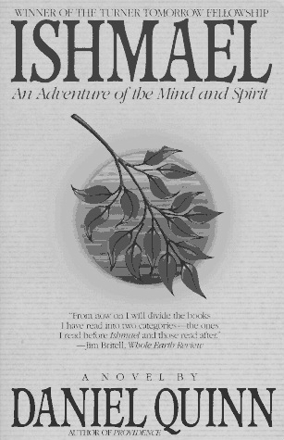

Since first published in 1992, the novel has grown into an international bestseller, garnered rave reviews, and has been adopted for classroom use in schools such as Dartmouth, the Naval Academy, Stanford University and locally.
ATLeavers
Ishmael
community
Collective

Walk
Away !
We are a diverse group of individuals inspired by the writings of Daniel Quinn and other visionary thinkers and have discovered the responsibility to restore our society to a healthy state of affairs for all humanity and the community of life. We aim to demonstrate how people can live satisfying and sustainable lives based on the accumulated from over 300,000 years of the successful human experience.

Anyone and everyone is welcome to the group. We challenge those who sees an unnecessary decline in the quality of life and to join us in improving the state of the world by acting locally with a sense of optimism.

We view the human experience in a holistic and integral way. We are not affiliated with any official or unofficial religious, political, economic, environmental, regional, national, commerce, or militia groups. We do support ideas in many of these groups but do so in pursuit of a vision that is free of cultural flaws.

The ATLeavers do not ask or suggest for donations, solicit products, request volunteer work, or ask anything of our visitors and members. The topics of group discussions include in various degrees: history, ancient & modern cultures, religion & spirituality, social philosophies, environmentalism, technology, politics, social reform, and agriculture.

Our human society is more comforting when we live the following model:


But too often we are encouraged to live life in the following model:



Elements of our Vision

“Saving the World” mutually for ourselves and the community of life

There is no ONE right way to live and the diversity of life proves it

Minimizing the culture of maximum harm

The savage jungle story is a myth.

The Agricultural Revolution is a myth.

Humanity is not flawed.

With the offering of truth which do you take?

The Blue Pill

Or The Red Pill

Movie reference: The Matrix

