“Get a job, make some money, work till
you’re sixty, then move to Florida and die”

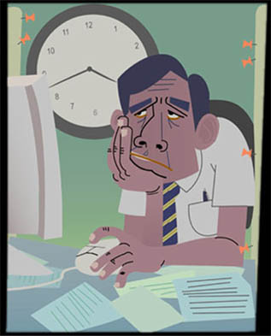

There must be more to life than this.

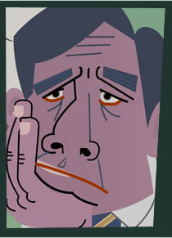

No religion, no selling, no pills…just real answers.

www.readishmael.com

