Read the book that inspired:  - Pearl Jam’s album YIELD  - The major Hollywood motion picture INSTINCT starring Anthony Hopkins and Cuba Gooding Jr.  - Ted Turner to award the author $500,000, the largest amount ever awarded to a single book  - The CEO of Interface, a multi-billion dollar corporation, to restructure his entire company to becoming sustainable  - Teachers to use it in 1,000’s of schools in over 200 subjects  - Oprah to invite the author to her show after she was told to read it not once, but six times, by friends such as Whoopi Goldberg  Ishmael  by Daniel Quinn    Time is running out | “From now on I will divide the books I have read into two categories - the ones I read before Ishmael and those read after.” - Jim Britell, Whole Earth Review  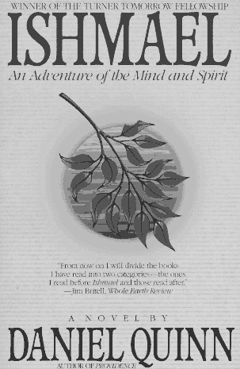___________________________________  TEACHER SEEKS PUPIL  Must have an earnest desire to save the world. Apply in person.  It was just a three-line ad in the personals section, but it launched the adventure of a lifetime… | Books by Daniel Quinn include:  These books should be available through your local library and bookstore. Learn more at http://www.ReadIshmael.com  ____________________________________________________________________  Interested in Ishmael?  What: Detroit Ishmael Leavers Meeting  When: 1st and 3rd Thursday each month  Where: The Greenhouse, 22757 Woodward, Southwest corner of WW/9 mi, just above Professional Guitars; (248) 336-9241  Who: Anyone with an interest in Daniel  Quinn’s work  Why: To discuss Quinn’s writings and coordinate activities that increase readership  E-mail/Web: wilgenbusch@hotmail.com  http://www.DetroitIshmael.org
  Ishmael (1992)  Providence (1995)  The Story of B (1996)  My Ishmael (1997)  Beyond Civilization (1999)  After Dachau (2001)  Man Who Grew Young (2001) | 