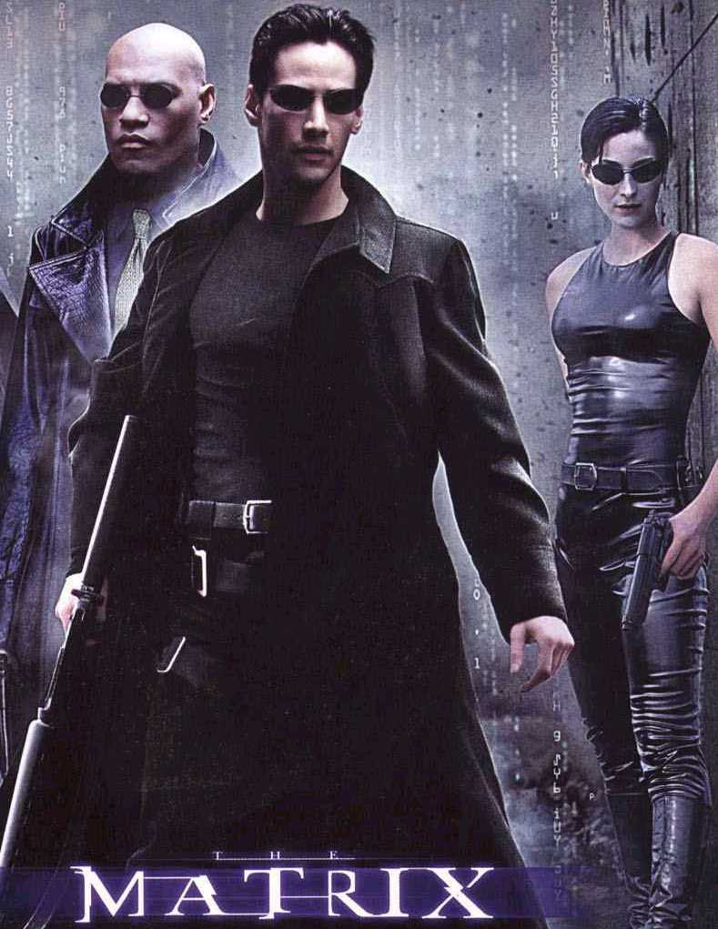

"In the movie, ‘The Matrix’, Neo has a choice of taking a red pill, which frees his mind from its prison and enables him to see reality and save humanity, and a blue pill, which simply leaves him to remain trapped in his illusion but remain ignorant of his captivity. Reading Ishmael was my own ‘red pill’. Which pill would you take?"

-Elyas Bakhtiari, San Antonio TX





by Daniel Quinn

The award-winning book Ishmael is the “red pill” for thousands of people throughout the world! It systematically and irrefutably exposes the root cause of many social and environmental problems we face today. Why don’t you take the red pill today, you will never be the same again!
Proudly sponsored by the Detroit Ishmael Leavers

e-mail: wilgenbusch@hotmail.com
web: http://www.detroitishmael.org/
learn more at: http://www.readishmael.com/

